Database System Engineering and Distributed Backend Development
Course Code: 25CS1302E
Week-2
Name: S. Poojitha
Roll no: 2520030110
Query 1:
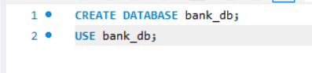
Output:
Query 2:
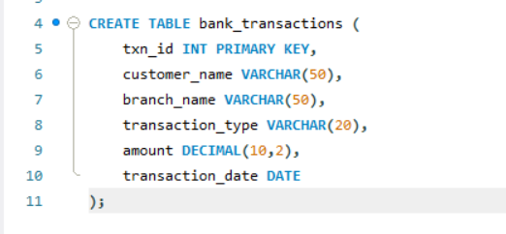
Output:
Query 3:
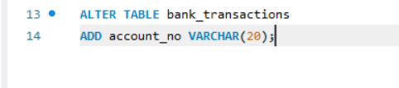
Output:
Query4:
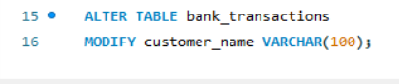
Output:
Query 5:
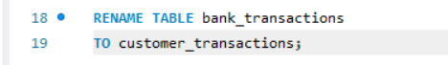
Output:
Query 6:
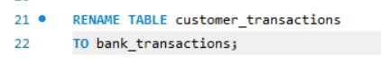
Output:
Query 7:
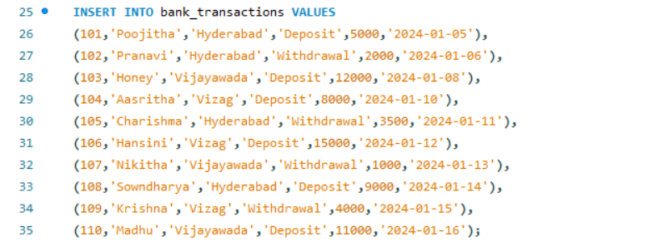
Output:
Query 8:
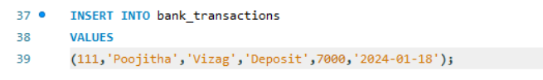
Output:
Query 9:
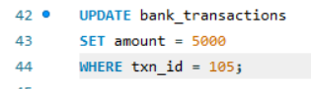
Output:
Query 10:
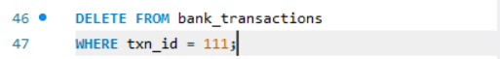
Output:
Query 11:
Output:
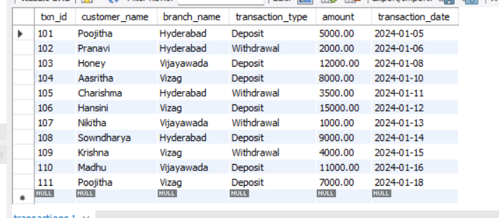
Query 12:
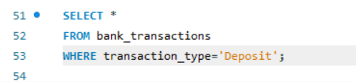
Output:
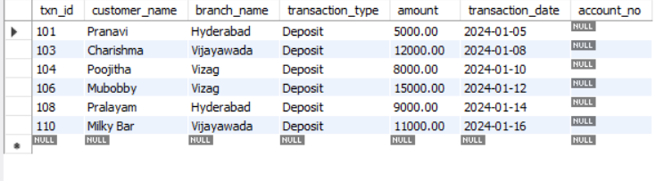
Query 13:
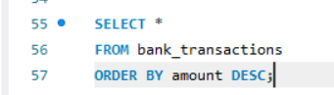’
Output:
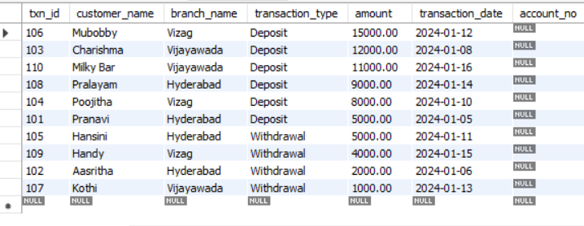

Query 14:
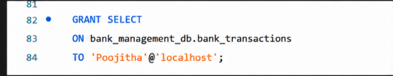
Output:
Query 15:
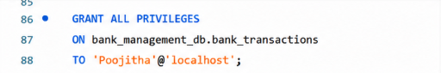
Output:
Query 16:
9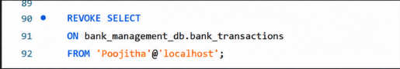
Output:
Query 17:
Output:
Query 18:
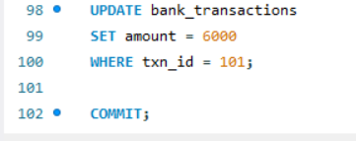
Output:
Query 19:
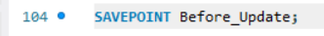
Output:
Query 20:
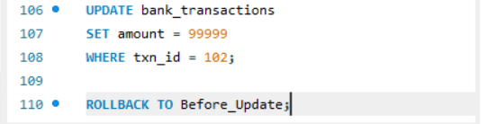
Output:
Query 21:
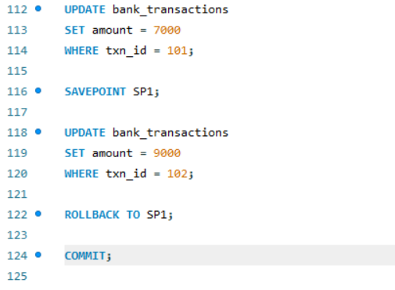
Output:

